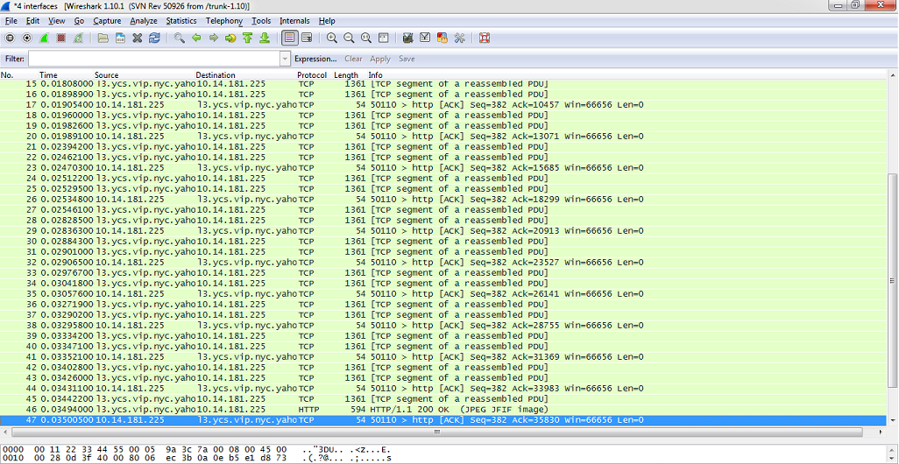

Source: 10.14.181.225

Step 3:

|  |  |
| --- | --- |
| Range of ethernet | Ethernet Payload |
| 4752bits | 0xb8c7 |

Step 4:

Protocol Overhead = frame size – payload size/frame size = 4752 – 3480/4752 = 0.267676767

Step 5:

1. Destination: Cimsys_33:44:55 (00:11:22:33:44:55)
2. Source: Cisco_3c:7a:00 (00:05:9a:3c:7a:00)